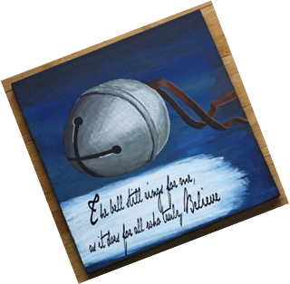KINDERGARTEN NEWS…

Vol. 8 No. 15 Mrs. O’Connor’s Class 2015-16 Date: Dec. 11th-18th

**HOMEWORK ACTIVITIES:**

**-Math Homework: see attached activities**

**-Sight word review**

**-Reading Calendar**: Please keep track of the books you share.

# SPECIAL SCHEDULE

**Monday: PE**

**Tuesday: Art, Library**

**Wednesday: Late Start, Tech, PE, Central Jr. High Music assembly**

## Thursday: Tech, Art, 3rd grade Buddies (gingerbread houses);

## Friday: PE (Polar Express Day in Kindergarten… Wear pjs to school!)

### Literacy News…

In **Language Arts** this week we will reading some of our favorite Christmas books. We will apply the skills we have been studying in our fiction unit. We will be going on a text feature/signal scavenger hunt. As we read we will be looking at end marks, watching for quotation marks, and noticing if there are capital or italicized words. Also, in writing, we will be reviewing our writing portfolio. We will be transferring our work in the FUNctional unit to our portfolio. Some of our work from the unit will be sent home.

**TOPICS OF CONVERSATION:**

**Ask your child about Hanakkah, Kwanzaa, St. Nicholas Day, and La Posada.**

**Ask them what is a menorah, dreidel, kinara, or pointsettia.**

|  |
| --- |
|  |

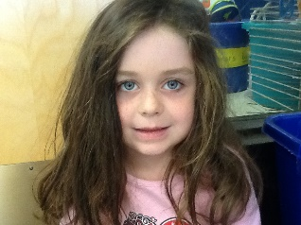

STAR of the WEEK update.

**Brooklyn Lynch** is the next STAR OF THE WEEK! We can’t wait to see her presentation.

##### **Math News…**

We will review the following concepts next week: Decompose numbers less than or equal to 10 into pairs in more than one way, e.g., by using objects or drawings, and record each decomposition by a drawing or equation (e.g., 5 = 2 + 3 and 5 = 4 + 1).

**Please remember all gingerbread house supplies are due by Tuesday, December 15th .**

#### Science/Social Studies News…

We will continue to explore different countries and customs around the world.